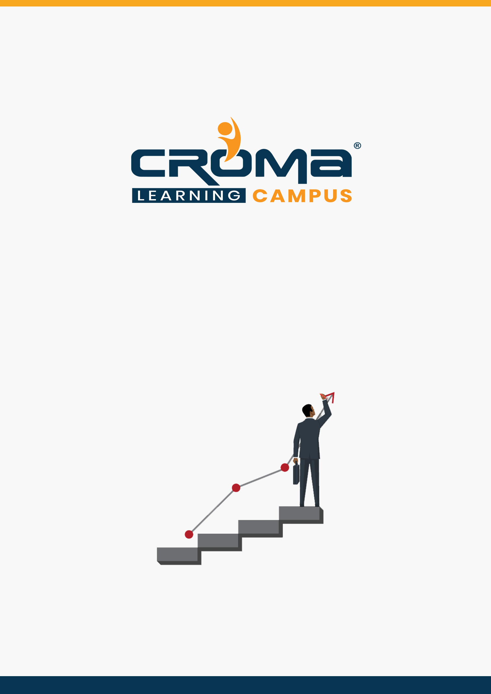

**Salesforce Admin Training Curriculum**

**STRUCTURE**

**www.cromacampus.com | helpdesk@cromacampus.com | +91-120-4155255**

**Salesforce Admin Training Course Content**

*“Enhance your Skills with a cutting-edge Curriculum of Salesforce Admin Training Program”*

**Course Objectives:**

* Master the Salesforce Administration concepts comprehensively.
* The course we offer ensures job success and acquire all related skills.
* Clear the certification exam with all the skills that have been gathered during the course.
* Learn to configure and setup the Salesforce account so that you can collect, retrieve, or analyze the data related to your customer base, precisely.

**Course Description:**

Once Salesforce Admin Certification Course will be finished, you will learn all Salesforce admin concepts - SFC data models, various basic terms of Salesforce, a profound comprehension of the salesforce security model, salesforce pinnacle triggers, salesforce test classes, and Salesforce automation alternatives.

You will almost certainly ace the Salesforce clouds like sales cloud, community cloud, service cloud, marketing cloud, analytics cloud, and so forth., report age, dashboards, and the essentials of Salesforce integration.

You would realize how to utilize validation rules, integration techniques, formula field the relationship of Salesforce objects, work process environments etc. Take up our training to learn Salesforce admin online and embody all the skills of a professional Salesforce admin.

There are various benefits that you get when you learn Salesforce admin online with Croma Learning Campus and they are as follows-

* All the sessions are conducted in a real-time environment
* The learners are put in a collaborative ecosystem of learning
* Surprise quizzes, live debates are a part of learner’s daily routines
* The course covers all Salesforce Admin concepts in-depth.
* It is a comprehensive training that covers practical and theoretical training
* It comes with an interesting range of Salesforce admin training materials.
* Learners get real-life projects-based learning and an assured practical training in tools.

**Course Content Quick Overview:**

* Module 1: Introduction to Salesforce
* Module 2: Force.com Database Configuration
* Module 3: Workflows in Salesforce
* Module 4: Formula Fields and Validation Rules
* Module 5: Record Types/Page Layout
* Module 6: SFDC Security Model
* Module 7: Data Management
* Module 8: Reports & Dashboard
* Module 9: App Design
* Module 10: Placement Guide

**Course Content:**

**Chapter 1: Salesforce.com Overview**

* Cloud Computing Overview
  + Introduction to Cloud Computing
  + Introduction to IAAS, PAAS, SAAS
  + Deployment Models
  + Introduction to CRM
  + How can CRM help?
  + Evolution of CRM
  + Advantages of CRM
  + A view of available of CRM Products
* Introduction to Salesforce CRM
  + What is Salesforce.com?
  + Salesforce CRM Overview
  + Why Salesforce?
  + Understanding Salesforce Architecture
  + Services Provided by Salesforce
  + Salesforce Vs Other Cloud
  + Market Demand for Salesforce CRM.
  + Job Market and growth in CMR industry.
  + Salesforce Editions, Licenses and Pricing
  + Salesforce Sandboxes (Dev, QA, Full, Prod.)
  + Creating First SFDC Dev Account
  + Salesforce.com CRM Editions
  + Salesforce.com Navigation – Overview
  + Creating Salesforce Developer Account
* Salesforce Applications
  + Sales Cloud, Service Cloud, Custom Cloud
  + Rapid application Development, Cost Reduction & Quality Products
* Salesforce Certifications
  + Certified Administration (201)
  + Certified Advanced Administration (211)
  + Salesforce certified platform developer 1 (PD1: 401)
  + Salesforce certified platform developer 2 (PD2: 501)
* Organization Setup
  + Salesforce Quick Navigation Walk Through
  + Popular Std. Objects and their purpose
  + Set up Menu Intro (Various OOB and Dev Options)
  + Popular in different other objects
  + Organization proﬁle, Currency etc.
  + Salesforce User Interface Overview

**Chapter 2: Force.com Database Configuration**

* Objects in Salesforce
  + Types of objects available in salesforce
  + Standard Objects
  + Custom Objects
  + Use of Standard Objects and Custom Objects in Salesforce
  + Difference between standard and custom object
  + Limitations of Standard Objects
* Tabs in Salesforce
  + Introduction to tab
  + Assigning tab to object
  + Types of Tab - Custom Object Tabs, Visualforce, Web tab, Lightning Page tabs
* Intro on various Data Types/Fields
  + Various data type fields creation
  + Standard Data types
  + Read only Data types
  + Relational Data types
* Roll-Up Summary Fields and its features.
* Limitations of Roll-up Summary Fields
  + Required, External Id, Default Value and Unique fields
* Object Relationships
  + Introduction to Relationships
  + Need of Relationships in salesforce
  + Brief on Types of relationship
  + Master-Details, Lookup, Self-relationship, External lookup relationship, Indirect lookup relationship, Many-to-many relationships (Junction object), Hierarchical relationship
* Deep in to Junction object
* Use of Junction object.
  + Difference between master-detail and lookup relationship
  + How to convert lookup to master details and vice Versa.

**Chapter 3: Workflows in Salesforce**

* Defining Workflows
* Workﬂow Rules
* Types of evaluation criteria in Workﬂow rules
* Introduction to Approval Process
* Understanding Approval steps, Approval actions, Rejection actions
* Introduction to process builder and its action
* What is the difference between workﬂow and process builder?
* Workflow Actions
  + Email Alert
  + Task Create
  + Field Update
  + Outbound Message
* Difference between Evaluation Criteria and Rule Criteria
* Workflow Vs Trigger
* Email Templates Overview
* Email Templates for Email Notiﬁcations
* Sending Email Templates
  + Sending Single emails
  + Sending Mass emails.
* Types of Templates
  + HTML (Using Letter Head)
  + Custom HTML (without using letter head)
  + Visual force Email Templates

**Chapter 4: Formula Fields and Validation rules**

* Understanding of formula fields
* Purpose of formula field
* Types of formula field in salesforce
* Text/Logic/Math/Date functions & Other popular functions
* Introduction to cross object formula
* What is the need for object formula?
* Introduction to validation rule, Need, and Various popular functions
* What is the difference between the formula field and Rollup summary in Salesforce?

**Chapter 5: Record Types/Page Layouts**

* Page Layouts
  + Defining Page layouts
  + Field order changes
  + Adding custom buttons and links
  + Defining required and read only fields
  + Adding related list
  + Adding Sections in Detail page
* Record Types
  + To create and maintain record types for your organization.
  + Display different page layouts and picklist values based on record types.
  + Uses of Record Types
* Field Dependencies
  + Controlling field/Dependent field?
  + Making dependent pick list fields
  + Limitations

**Chapter 6: SFDC Security Model**

* Introduction to User Management, User Object
* Different types of user licenses available - Salesforce, Salesforce Platform
* Roles and Proﬁles
* Creating Users
* Permission Sets
* Profile Vs Permissions Sets
* Password Policy
* IP Address security
* Login hours & Session settings
* OWD -Public Read/Write, Public Read, private only
* Manage record access with the role hierarchy
* Sharing record-Manual and owner based
* Manage field-level security

**Chapter 7: Data Management**

* Introduction to Data migration
* Overview to Data loader and its installation process
* Data Loader Action-Insert, Update, Delete, hard delete
* Configure the Data Loader via command line
* Attachment upload with Data loader
* Data Loader Vs Other Third Party ETL Tools
* Introduction to salesforce import wizard
* Mass Transfer Records and Delete of Records
* Difference between Data loader and import wizard
* Mass Transfer Records and Delete of Records
* Back up data with a weekly export

**Chapter 8: Reports & Dashboard**

* Introduction to Data Visualization-Reports and Dashboard
* Introducing Reports and Custom Reports
* Types of report-Tabular, summary, Matrix, and joint report
* Understanding the formula field and bucket field.
* Add a chart and a few other features like highlighting
* Understanding -Reporting Snapshots, Report types
* Overview to the dashboard and its types
* What is a dynamic dashboard?
* Adding Dashboard Snapshots to Home Page
* Understanding Sharing & Security of Reports-Dashboards

**Chapter 9: App Design**

* What is AppExchange?
* Installation of an App
* Uninstall an App
* Create a custom app
* Service Cloud Console

**Chapter 10: Placement Guide**

* What is an Interview?
* Tips to clear an Interview
* Common Interview questions and answers
* Salesforce Admin Interview Questions and Answers
* Resume Building Guide
* Attempt for Salesforce Admin Global Certification Exam
* Start applying for Jobs

**All About Salesforce Certified Administrator (ADM 201)**

This is an exam guide to refer for people interested in learning Salesforce administration essentials and want to attempt for Salesforce ADM 201 certification exam. This guide provides information about the target audience for the Salesforce Certified Administrator exam, and a complete list of exam objectives—all with the intent of helping you achieve a passing score. We highly recommend a combination of on-the-job experience, online Training Program, and self-study to maximize your chances of passing the exam.

The topics to be covered in this exam guide include:

* Target audience for Salesforce Certified Administrator Exam
* About the Exam
* Exam Outline
* Sample Questions for the exam

Let us have a deep dive on all these bullets one by one.

**Target audience for Salesforce Certified Administrator Exam:**

* The Salesforce Certified Administrator has experience performing as a Salesforce Administrator, including practical application of the skills and concepts noted in the exam objectives.
* The candidate should have a general knowledge of the features available to the end users and the configuration options available to a Salesforce Administrator.
* The candidate should be capable of maintaining a Salesforce organization, responding to common business requirements, and performing administrative functions using the current version of the Salesforce features.

**About the Exam:**

* Content: 60 multiple-choice/multiple-select questions
* Time allotted to complete the exam: 105 minutes
* Passing score: 65%
* Registration fee: USD 200, plus applicable taxes as required per local law
* Retake fee: USD 100, plus applicable taxes as required per local law
* Delivery options: Proctored exam delivered onsite at a testing center or in an online proctored environment.
* References: No hard-copy or online materials may be referenced during the exam.
* Prerequisite: None required.

**Exam Outline:**

The Salesforce Certified Administrator exam measures a candidate’s knowledge and skills related to the following objectives. A candidate should have hands-on experience as a Salesforce Administrator and have demonstrated the application of each of the features/functions below.

* Organization Setup – 3%
* User Setup – 6%
* Security and Access – 14%
* Standard & custom objects – 12%
* Sales & Marketing Apps – 15%
* Service and Support Applications – 12%
* Activity Management – 3%
* Data Management – 8%
* Analytics: Reports & Dashboard – 10%
* Workflows/Process Automation – 12%
* Desktop and Mobile Administration – 1%
* App Exchange – 1%

**Sample Exam Questions:**

**Question 1: What should a system administrator use to disable access to a custom application for a group of users?**

Choose one answer

A. Profiles

B. Sharing rules

C. Web tabs

D. Page layouts

---------------------------------------------------------------------------------------------------------------------------------

**Question 2: Universal Containers needs to track the Manufacturer and Model for specific car companies. How can the system administrator ensure that the selected Manufacturer provides the values available for the Model?**

Choose one answer

A. Create the Manufacturer field as a dependent picklist and the Model as a controlling picklist.

B. Create a lookup field from the Manufacturer object to the Model object.

C. Create the Manufacturer field as a controlling picklist and the Model as a dependent picklist.

D. Create a multi-select picklist field that includes both Manufacturers and Models.

---------------------------------------------------------------------------------------------------------------------------------

**Question 3: Sales representatives at Universal Containers need assistance from product managers when selling certain products. Product managers do not have access to opportunities, but need to gain access when they are assisting with a specific deal. How can a system administrator accomplish this?**

Choose one answer

A. Notify the product manager using opportunity update reminders.

B. Enable Opportunity Teams and allow users to add the product manager.

C. Use Similar Opportunities to show Opportunities related to the product manager.

D. Enable Account Teams and allow users to add the product manager.

---------------------------------------------------------------------------------------------------------------------------------

**Question 4: Which two should a system administrator consider before importing a set of records into Salesforce?**

Choose two answers

A. The import file should include a record owner for each record.

B. Currency field values will default to the personal currency of the record owner.

C. Data should be de-duplicated in the import file prior to import.

D. Validation rules are not triggered when importing data using the import wizard.

---------------------------------------------------------------------------------------------------------------------------------

**Question 5: Which two statements about custom summary formulas in reports are true?**

Choose two answers

A. Reports can be grouped by a custom summary formula result.

B. Custom summary formulas can reference a formula field within a report.

C. Custom summary formulas can reference another custom summary formula.

D. Custom summary formulas can be used in a report built from a custom report type.

---------------------------------------------------------------------------------------------------------------------------------

**ANSWERS TO SAMPLE EXAM QUESTIONS**

1. A, 2. C, 3. B, 4. A, C, 5. B, D

---------------------------------------------------------------------------------------------------------------------------------